DEVELOPERS HUB CORPORATION
Software Quality Assurance (SQA)
WEEK 5 – SECURITY TESTING & VULNERABILITY ANALYSIS
Student Name: Anam Saghir
Submission Date: 14th April 2026
Tool Used: OWASP ZAP
Application Under Test: http://demo.testfire.net

Software Quality Assurance (SQA) – Week 5
Security Testing & Vulnerability Analysis Report

1. Objective
The objective of this assignment is to understand and analyze common web application security vulnerabilities and to perform basic security testing using industry-standard tools.
This task helps in identifying weaknesses such as:
- Cross-Site Scripting (XSS)
- SQL Injection
- Authentication flaws
- Data exposure issues
Testing is performed on a real-world demo application using security tools.

2. Learning Focus

2.1 OWASP Top 10 Overview (Detailed)
The OWASP Top 10 represents the most critical web security risks.
1. Broken Access Control
- Users can access unauthorized data or perform restricted actions
- Example: Accessing admin panel without permission

2. Cryptographic Failures (Sensitive Data Exposure)
- Sensitive data (passwords, credit cards) not encrypted properly
- Example: Website using HTTP instead of HTTPS

3. Injection (SQL, Command, etc.)
- Malicious input executed as code in backend
- Example: SQL Injection (' OR 1=1 --)

4. Insecure Design
- Poorly designed system with weak security controls
- Example: No validation on user input

5. Security Misconfiguration
- Improper system settings expose vulnerabilities
- Example: Server revealing version info

6. Vulnerable and Outdated Components
- Using old libraries or frameworks
- Example: Outdated plugins with known exploits

7. Identification and Authentication Failures
- Weak login systems
- Example: No account lockout after multiple attempts

8. Software and Data Integrity Failures
- Data or software updates not verified
- Example: No checksum validation

9. Security Logging and Monitoring Failures
- Attacks not detected or logged
- Example: No alert system for suspicious login

10. Server-Side Request Forgery (SSRF)
- Server fetches malicious URLs
- Example: Accessing internal systems via URL input

2.2 Basic Security Testing Techniques
- Input validation testing
- Authentication testing
- Session management testing
- Manual payload injection (XSS, SQLi)
- Proxy-based request analysis

3. Tools Used

3.1 OWASP ZAP
OWASP ZAP is an open-source tool used for finding vulnerabilities.

3.2 Burp Suite (Community Edition)
Burp Suite is another popular tool used for intercepting and modifying requests.

4. Application Under Test
- Application Name: Altoro Mutual Demo Bank
- URL: http://demo.testfire.net
- Type: Banking Web Application (Demo)
- Purpose: Designed for security testing

5. Tasks Performed

5.1 Installation & Setup of OWASP ZAP
Steps:
- Download OWASP ZAP
- Install and launch the tool
- Configure browser proxy:
  - Address: 127.0.0.1
  - Port: 8080
Screenshot:
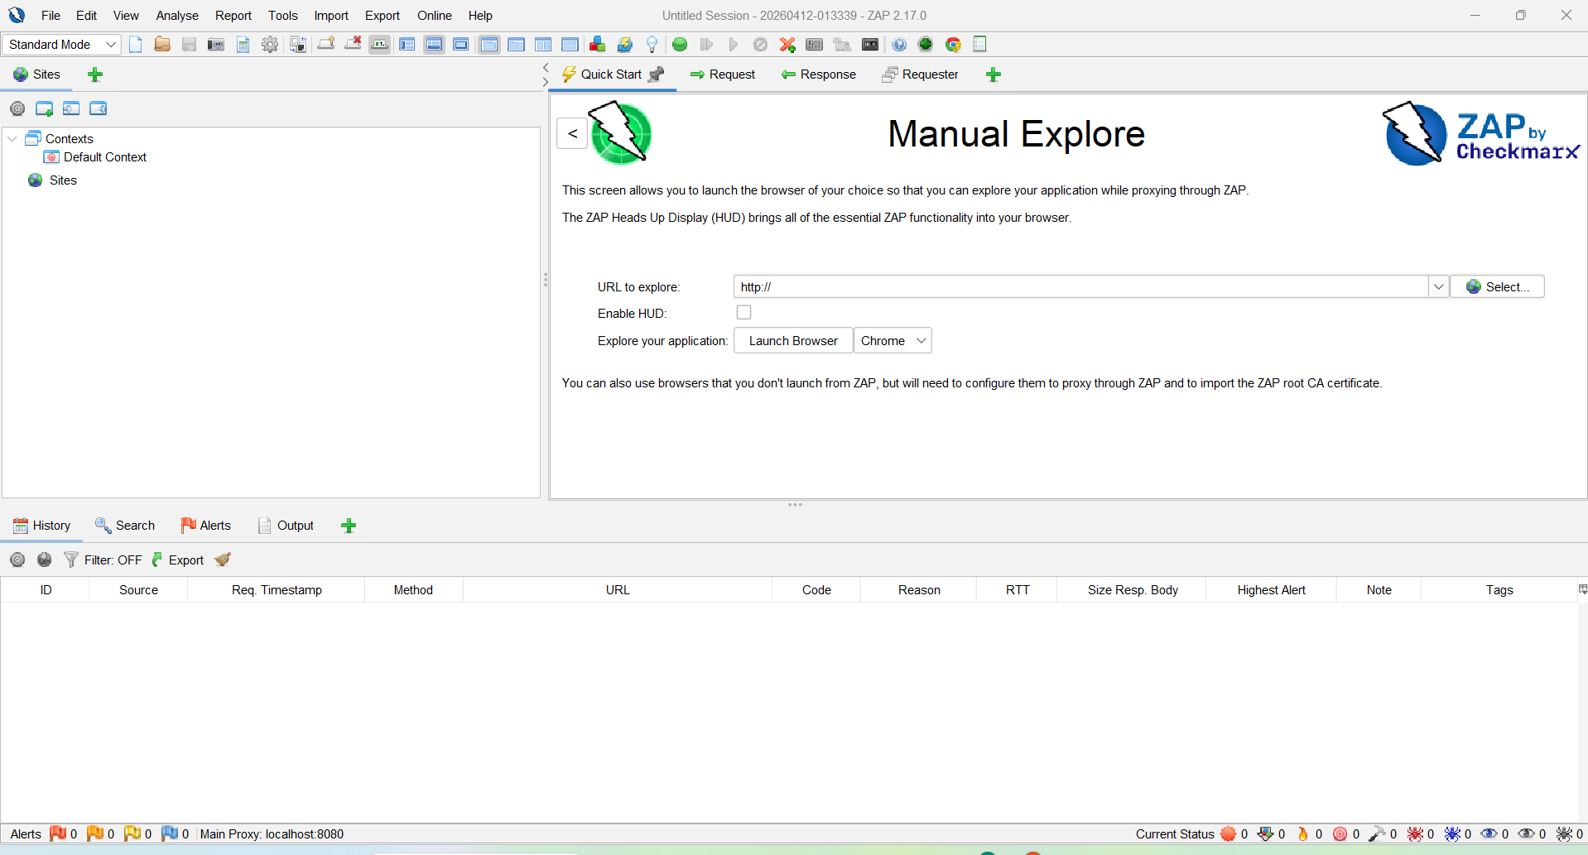
5.2 Intercepting Proxy Setup
Steps:
- Enable “Intercept” in ZAP
- Open browser and visit the website
- Capture HTTP requests
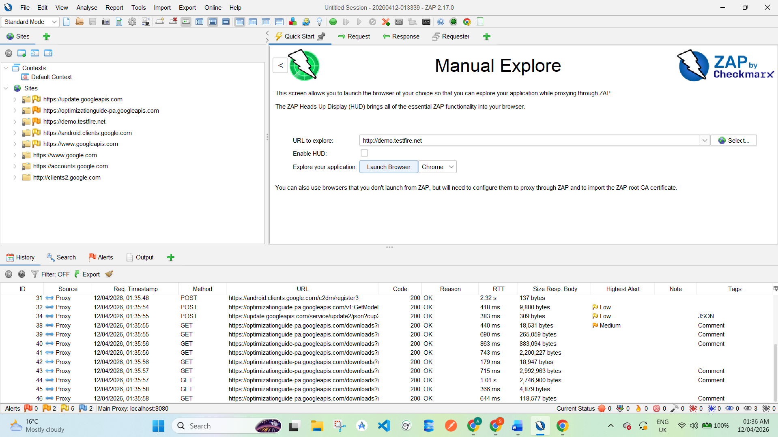
Screenshot Here: Intercepted HTTP request in ZAP
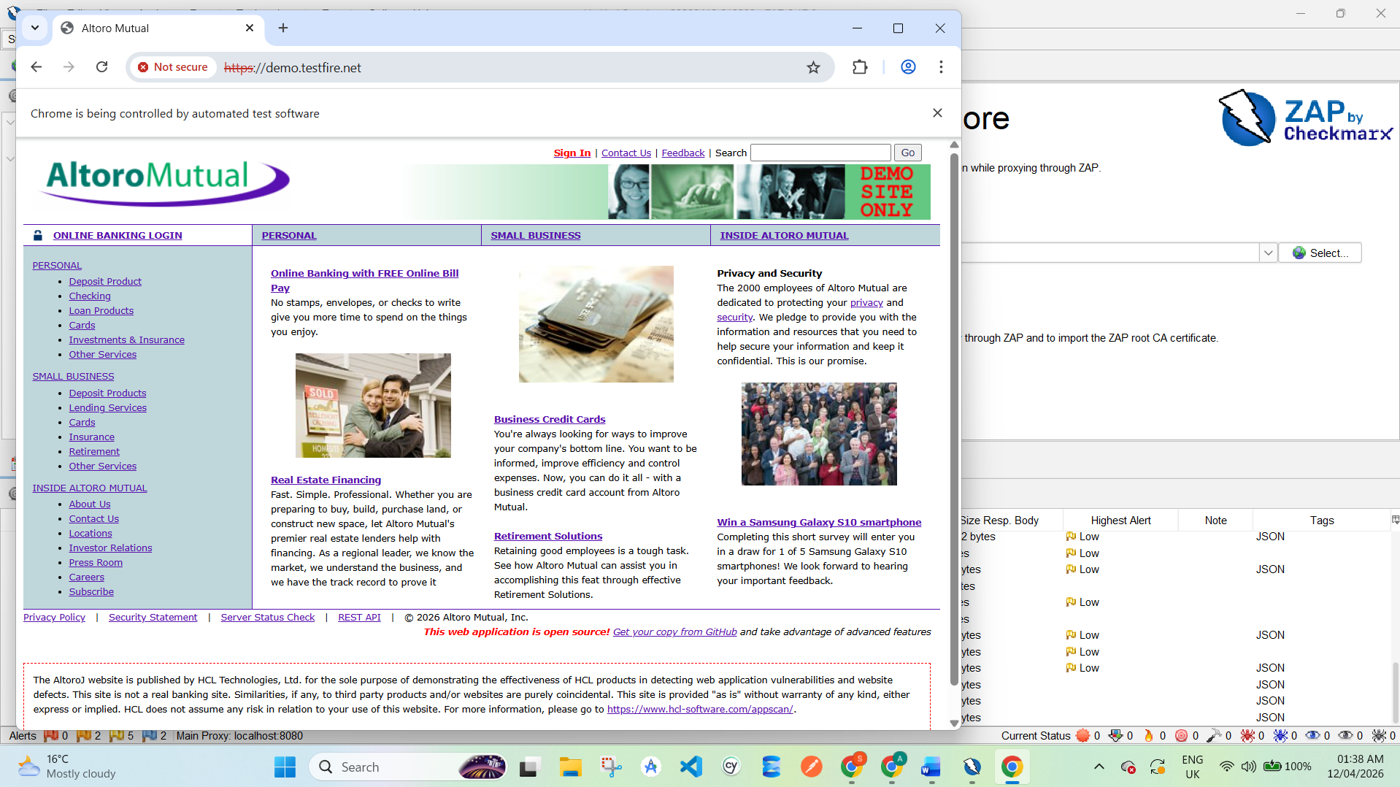

5.3 Passive Scanning
Steps:
- Browse the website:
  - Login page
  - Account section
  - Transfer page
- ZAP automatically scans traffic

Screenshot Here:
Alerts Tab showing vulnerabilities

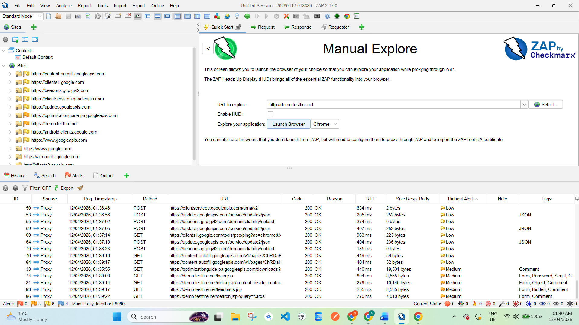

6. Security Testing on Web Application

6.1 Input Validation Testing
- Entered invalid data (special characters, scripts)
- Observed weak validation

6.2 XSS Testing
Payload Used:
<script>alert('XSS')</script>
Result:
- Script executed → XSS vulnerability confirmed

Screenshot Here:
Alert popup showing XSS

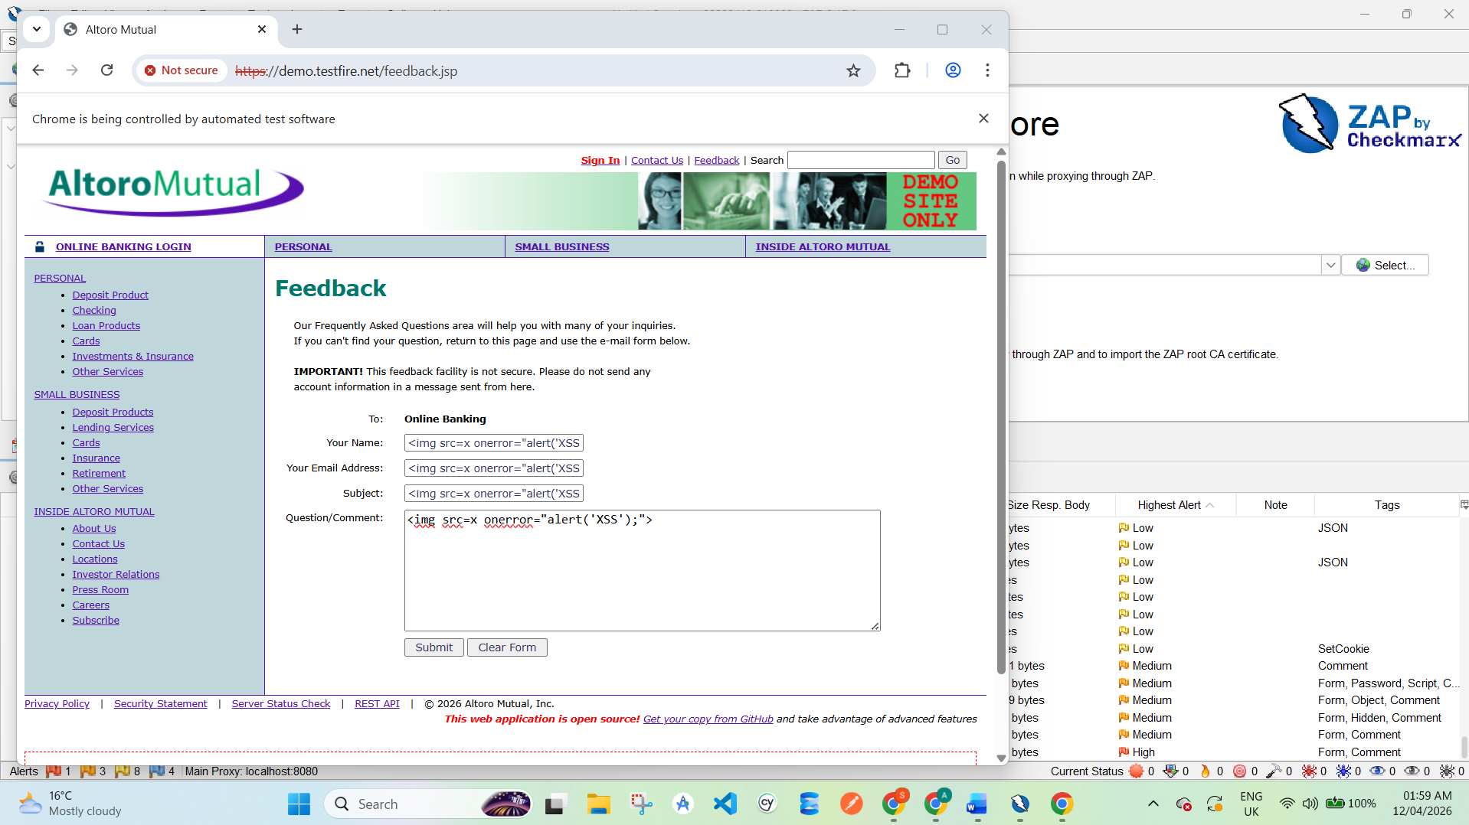
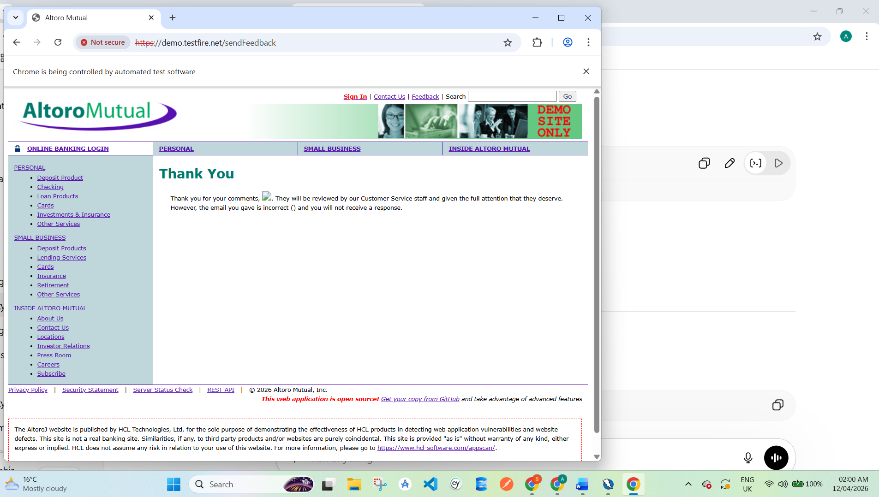
6.3 SQL Injection Testing
Payload Used:
' OR '1'='1
Result:
- Login bypass attempt successful / abnormal response
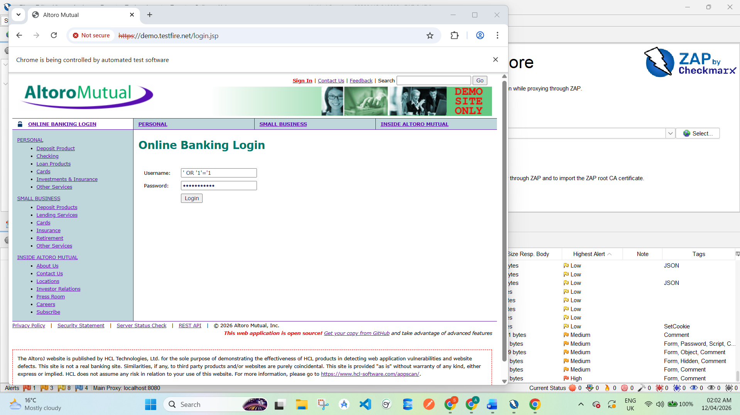
Screenshot Here:
Login page result
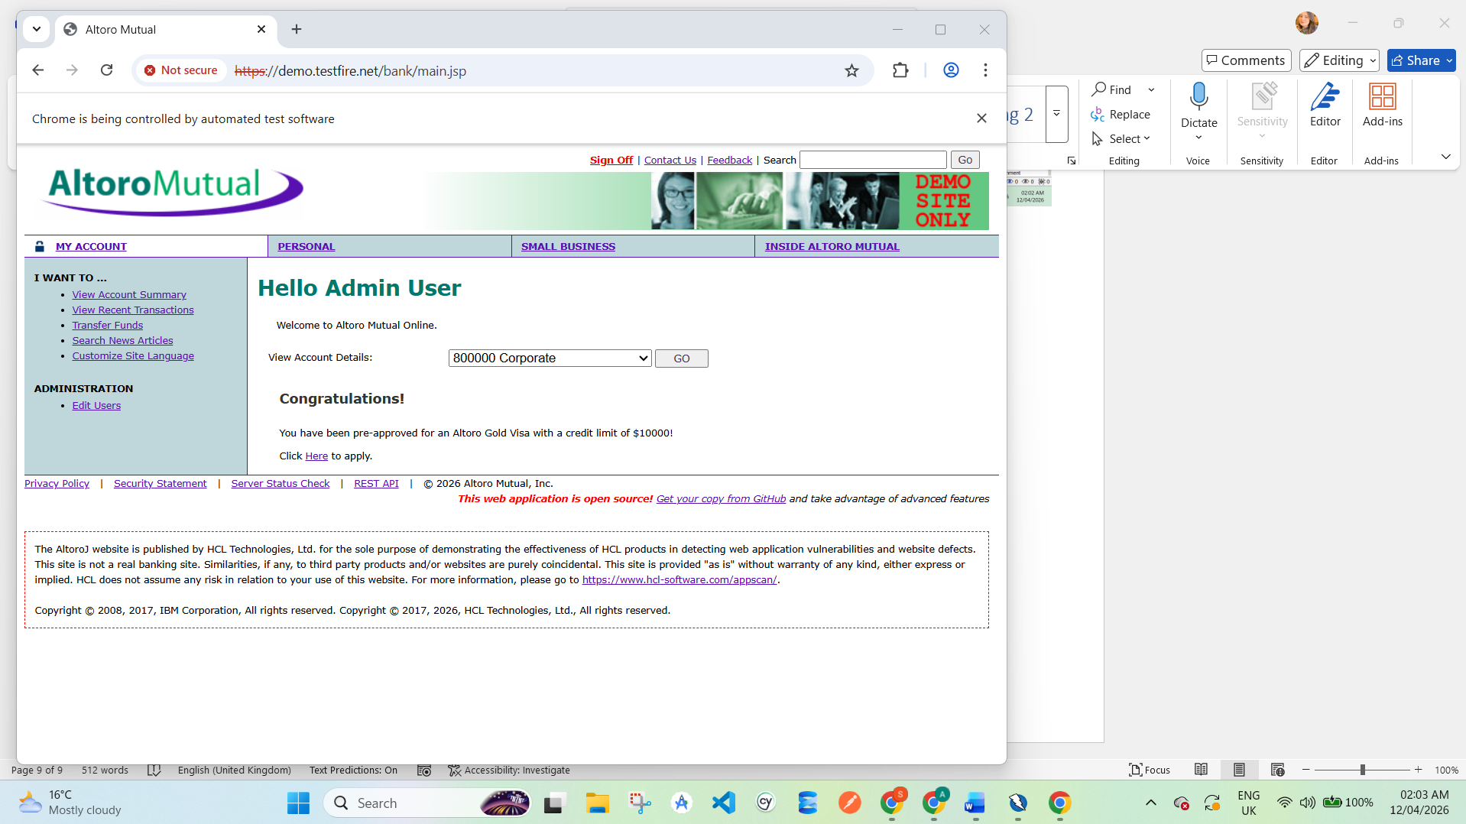
6.4 Login/Logout Security Testing
- No account lockout
- Weak authentication controls
Screenshot Here:
Login attempt evidence
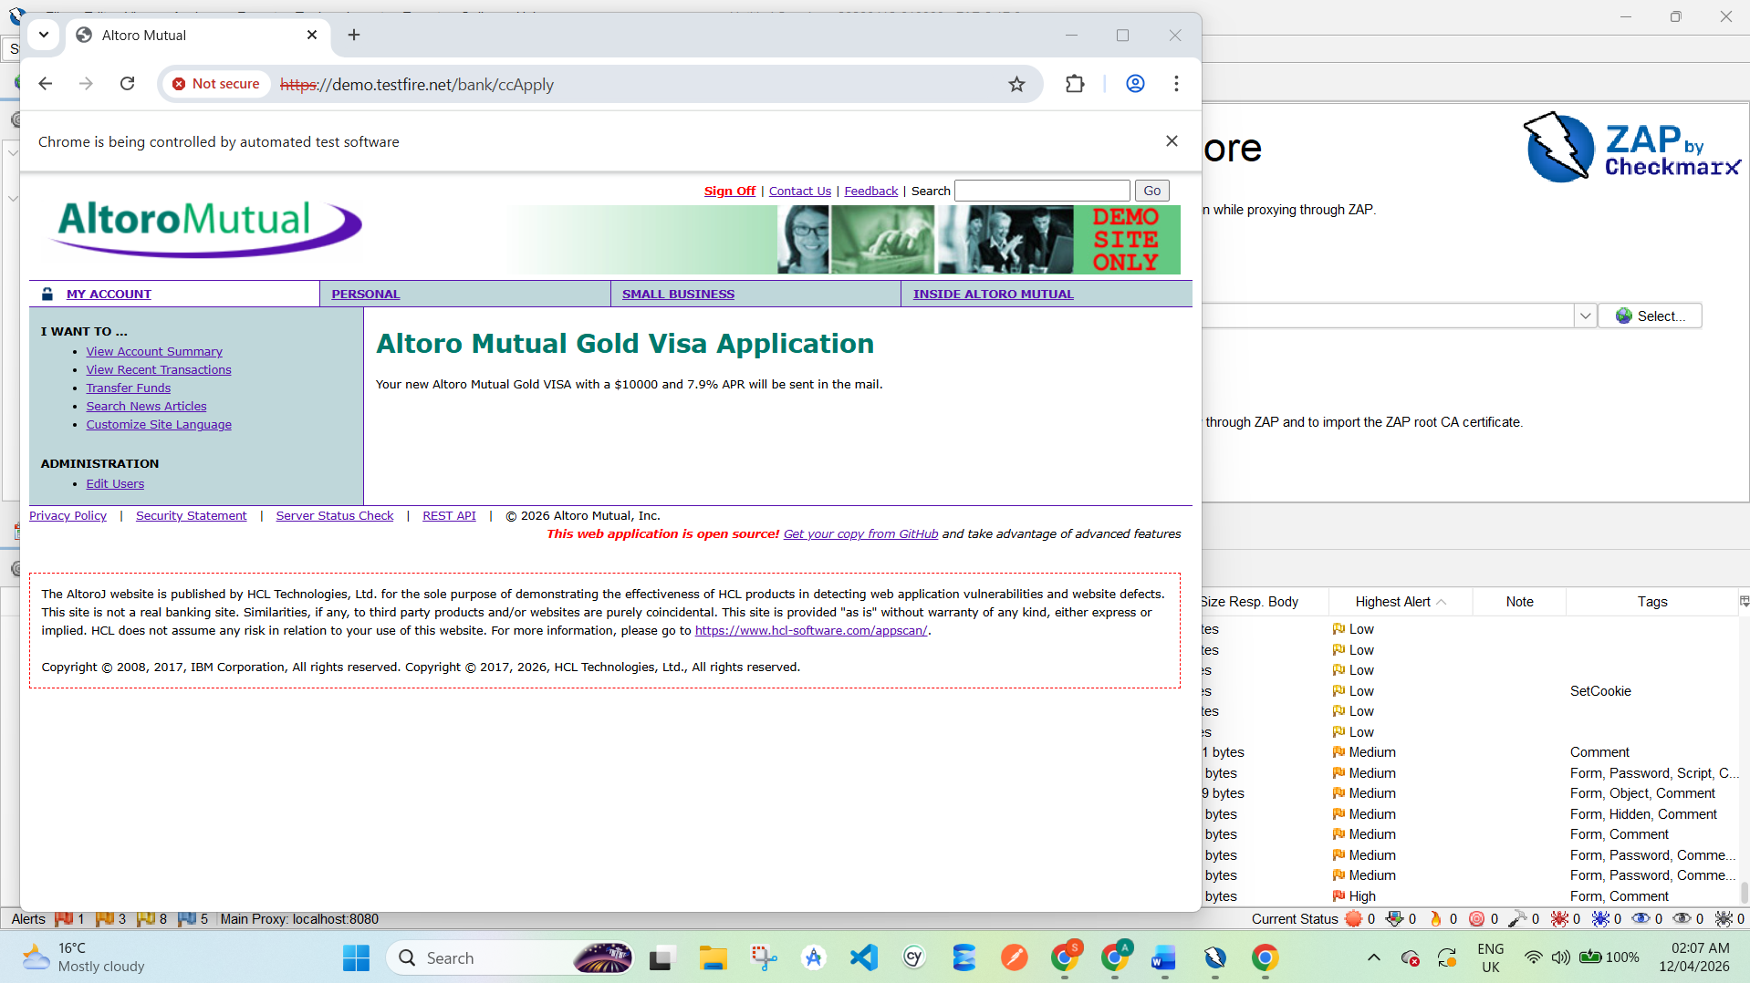

6.5 Session Timeout Testing
Steps:
- Login to account
- Stay idle
- Refresh page
Result:
- Session remained active → weak session handling
Screenshot Here:
Session still active

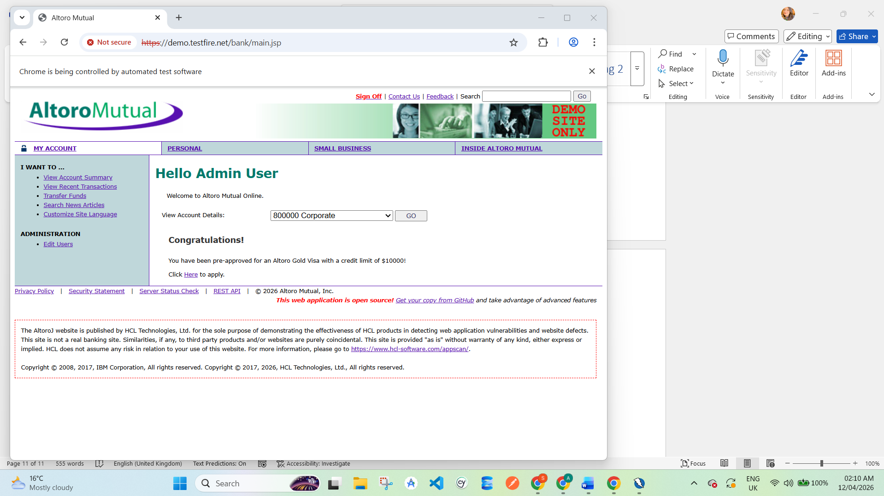

7. Vulnerability Report

VULN-001: Cross-Site Scripting (XSS)
- Description: Script execution via user input
- Severity: High
- Steps: Enter script in input field
- Evidence: Screenshot of alert
- Fix: Input sanitization, CSP

VULN-002: SQL Injection
- Description: Database manipulation via input
- Severity: Critical
- Steps: Use ' OR '1'='1
- Evidence: Login bypass
- Fix: Parameterized queries

VULN-003: Broken Authentication
- Description: Weak session handling
- Severity: High
- Fix: Secure session management

VULN-004: Sensitive Data Exposure
- Description: Data sent over HTTP
- Severity: Medium
- Fix: Use HTTPS

VULN-005: Security Misconfiguration
- Description: Server info exposed
- Severity: Medium
- Fix: Hide headers, secure configs

8. Summary of Findings
Vulnerability | Severity
XSS | High
SQL Injection | Critical
Broken Authentication | High
Sensitive Data Exposure | Medium
Security Misconfiguration | Medium

9. Conclusion
The security testing performed on the Altoro Mutual demo application revealed multiple vulnerabilities. These weaknesses can allow attackers to gain unauthorized access, execute malicious scripts, and compromise sensitive data.
Using tools like OWASP ZAP, QA engineers can effectively identify and analyze such issues.
Proper security measures must be implemented to ensure safe web applications.

